HOSPITAL MANAGEMENT SYSTEM

ABSTRACT
Hospital Management System is a web application developed using the Django Framework and SQLite database. The main objective of this project is to digitize hospital operations that are traditionally handled manually, reducing paperwork and improving efficiency.
Through this system, the following can be managed digitally:
- Patient Details
- Doctor Details
- Appointment Booking
- Billing
- Medicine Management
The system allows hospital staff to add, view, update, and delete patient and doctor records, book appointments between patients and doctors, generate bills automatically, and maintain medicine stock information. By replacing manual, paper-based processes with a digital solution, the project reduces errors, saves time, and makes hospital record management faster, more accurate, and more secure.

TABLE OF CONTENTS
TABLE OF CONTENTS 1
CHAPTER 1: INTRODUCTION 1
Introduction 1
CHAPTER 2: OBJECTIVES 1
CHAPTER 3: EXISTING SYSTEM 1
Existing System 1
Disadvantages 1
CHAPTER 4: PROPOSED SYSTEM 1
Proposed System 1
Advantages 1
CHAPTER 5: SOFTWARE REQUIREMENTS 1
CHAPTER 6: HARDWARE REQUIREMENTS 1
CHAPTER 7: TECHNOLOGIES USED 1
Python 1
Django 1
HTML 1
CSS 1
Bootstrap 1
SQLite 1
CHAPTER 8: SYSTEM DESIGN 1
CHAPTER 9: DATABASE DESIGN 1
Patient Table 1
Doctor Table 1
Appointment Table 1
Billing Table 1
Medicine Table 1
CHAPTER 10: MODULES 1
Patient Management Module 1
Doctor Management Module 1
Appointment Module 1
Billing Module 1
Medicine Module 1
CHAPTER 11: TESTING 1
Test Cases 1
CHAPTER 12: ADVANTAGES 1
CHAPTER 13: FUTURE SCOPE 1
CHAPTER 14: CONCLUSION 1
Conclusion 1
CHAPTER 15: REFERENCES 1
APPENDIX: SCREENSHOTS 1
APPENDIX: HOW TO EXPLAIN PROJECT STEPS IN VIVA 1

CHAPTER 1: INTRODUCTION

Introduction
Hospital Management System is a web-based application developed using the Django Framework. The main purpose of this project is to simplify the daily operations of a hospital by maintaining patient records, doctor information, appointment booking, billing details, and medicine records in a digital format.
Traditionally, hospitals maintain records manually, which requires more time and increases the possibility of errors. This project provides an easy and secure way to manage hospital data efficiently. It reduces paperwork, saves time, and improves the quality of healthcare management.

CHAPTER 2: OBJECTIVES
The main objectives of the Hospital Management System are:
- To maintain patient information digitally.
- To manage doctor details efficiently.
- To book appointments between doctors and patients.
- To generate hospital bills automatically.
- To maintain medicine stock records.
- To reduce paperwork and manual errors.
- To provide a user-friendly hospital management system.

CHAPTER 3: EXISTING SYSTEM

Existing System
In the traditional hospital management system, all patient records and billing details are maintained manually using registers and files. This process consumes more time and requires more manpower. Searching patient information is difficult, and there is a high chance of data loss or human error. Managing appointments and billing manually also increases workload and delays hospital operations.

Disadvantages
- Paper-based records
- Time-consuming
- Difficult to search data
- High risk of errors
- Data may be lost or damaged

CHAPTER 4: PROPOSED SYSTEM

Proposed System
The proposed Hospital Management System is developed using Django and SQLite database. It provides a digital solution for managing hospital activities. The system stores all records electronically and allows users to add, edit, delete, and view patient, doctor, appointment, billing, and medicine information easily. It improves accuracy, saves time, and increases efficiency.

Advantages
- Digital record management
- Fast data retrieval
- Easy billing process
- Secure database
- Reduced paperwork

CHAPTER 5: SOFTWARE REQUIREMENTS
The software required for developing this project includes:
- Python 3.x
- Django Framework
- SQLite Database
- HTML
- CSS
- Bootstrap
- Visual Studio Code
- Windows Operating System

CHAPTER 6: HARDWARE REQUIREMENTS
The minimum hardware requirements are:
- Intel Core i3 Processor or above
- 4 GB RAM
- 20 GB Free Hard Disk Space
- Keyboard and Mouse
- Internet Connection (optional)

CHAPTER 7: TECHNOLOGIES USED

Python
Python is a high-level programming language used to develop the backend logic of the project.

Django
Django is a Python web framework that follows the Model-View-Template (MVT) architecture. It provides built-in features for authentication, database management, and security.

HTML
HTML is used to design the web pages.

CSS
CSS is used to improve the appearance of web pages.

Bootstrap
Bootstrap helps create responsive and attractive web pages.

SQLite
SQLite is the database used to store all hospital information.

CHAPTER 8: SYSTEM DESIGN
The Hospital Management System consists of five major modules:
- Patient Management
- Doctor Management
- Appointment Booking
- Billing Management
- Medicine Management
All modules are connected to a central SQLite database through the Django framework.
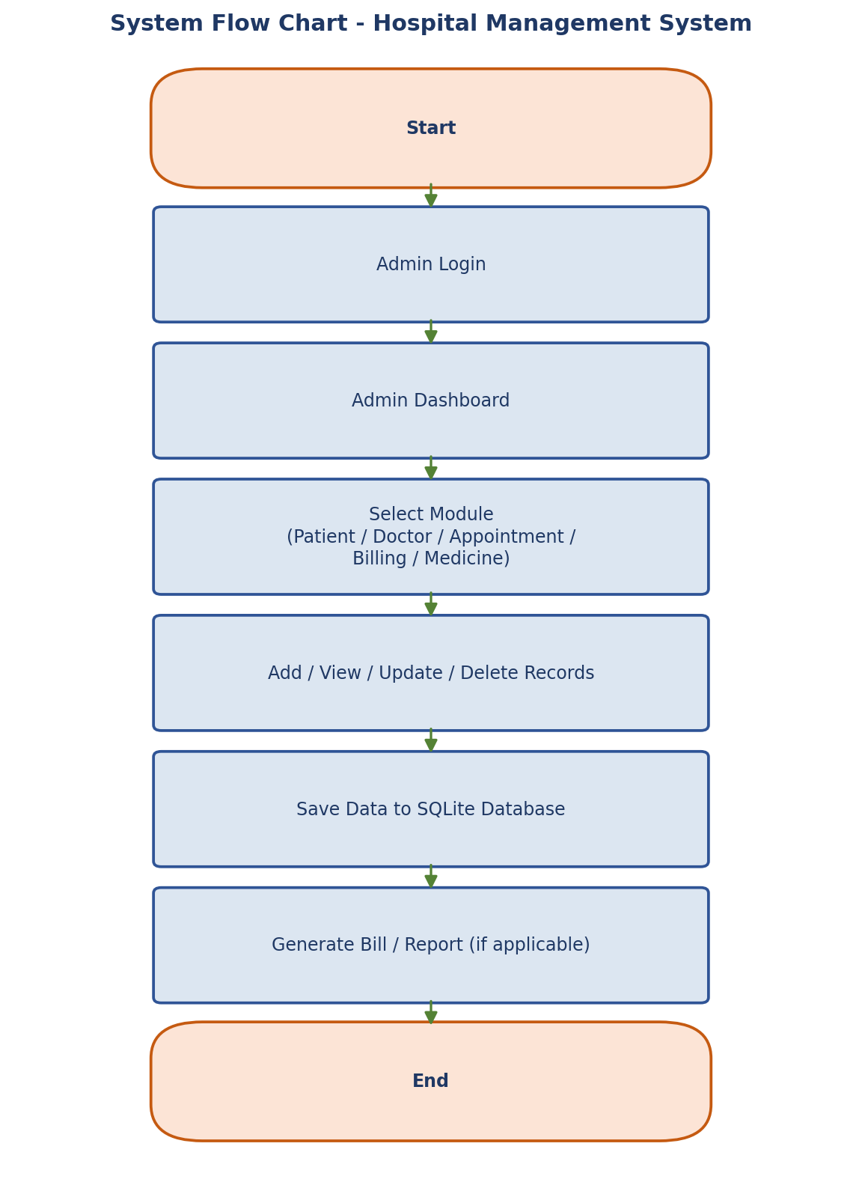
Fig 8.1: System Flow Chart

CHAPTER 9: DATABASE DESIGN

Patient Table
Stores patient details such as name, age, gender, phone number, and address.

Doctor Table
Stores doctor details including name, specialization, phone number, and email.

Appointment Table
Stores appointment information such as patient, doctor, appointment date, and appointment time.

Billing Table
Stores consultation fee, medicine fee, laboratory fee, other charges, discount, payment status, and total amount.

Medicine Table
Stores medicine name, company name, price, and quantity.
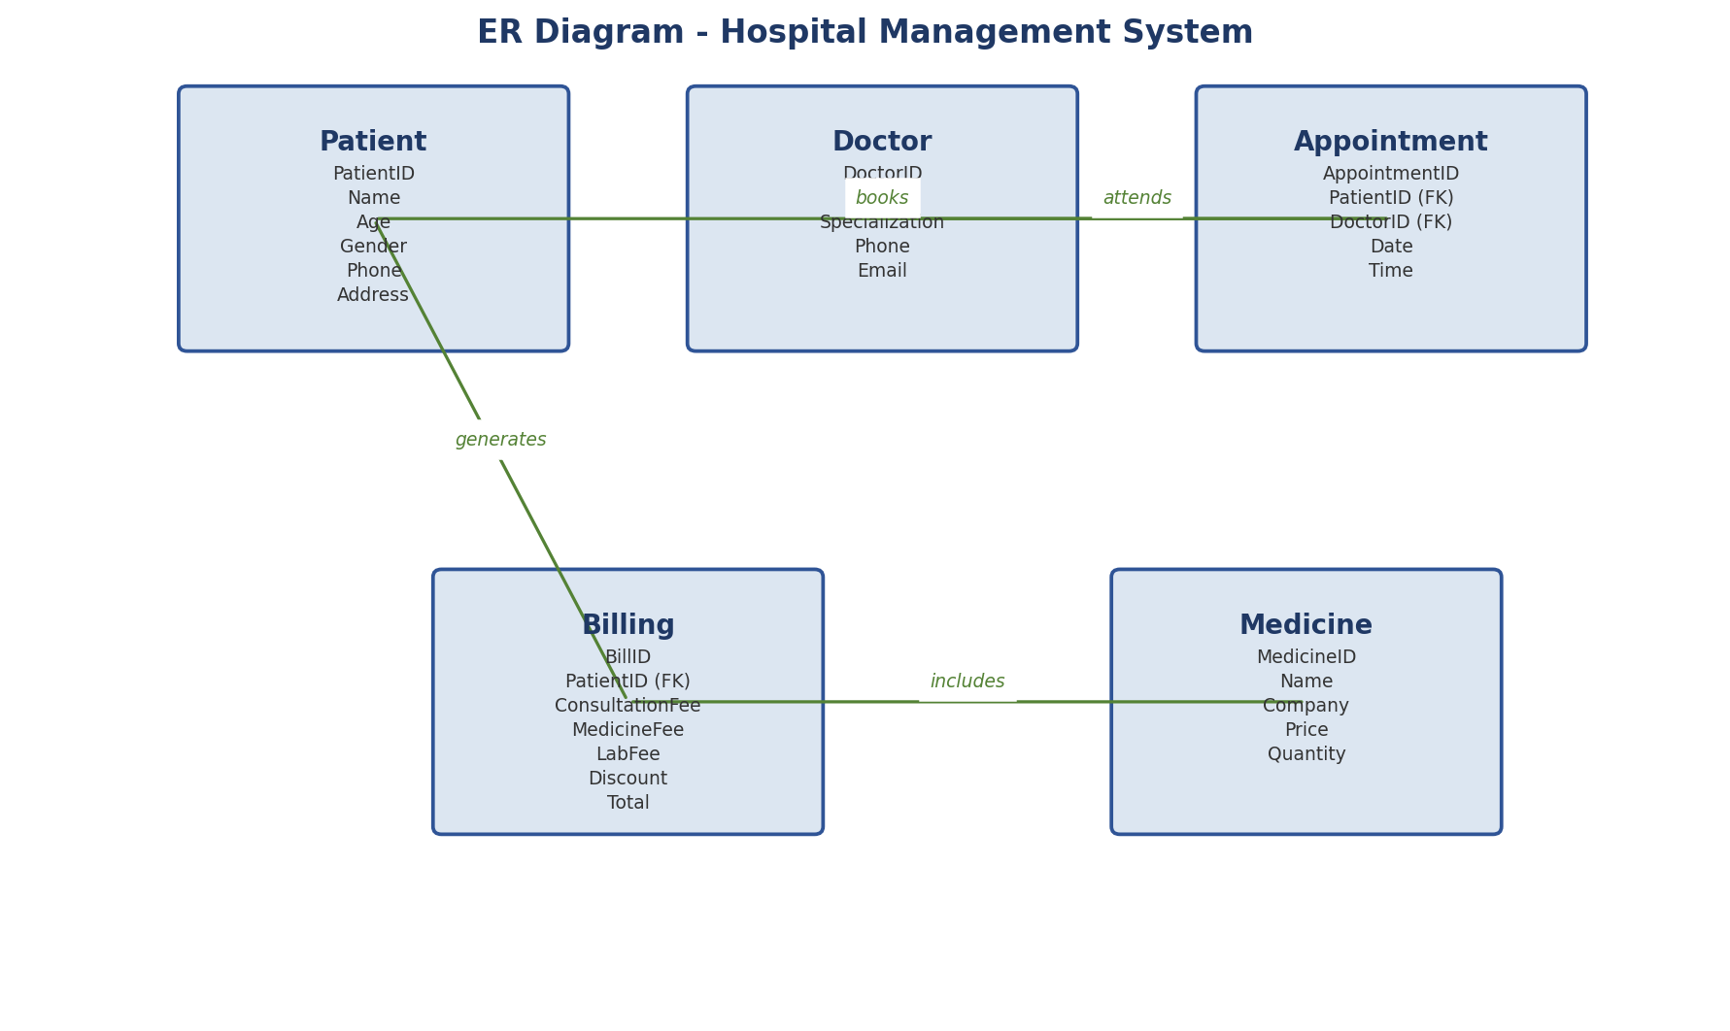
Fig 9.1: ER Diagram - Hospital Management System

CHAPTER 10: MODULES

Patient Management Module
This module allows users to add new patients, update patient details, delete patient records, and view all patients.

Doctor Management Module
This module stores doctor information including specialization and contact details.

Appointment Module
This module allows booking appointments between patients and doctors.

Billing Module
This module automatically calculates the total bill by adding consultation fees, medicine fees, laboratory fees, and other charges while deducting discounts.

Medicine Module
This module stores medicine details including price, quantity, and company information.

CHAPTER 11: TESTING
The project was tested successfully.

Test Cases
- Patient Registration – Passed
- Doctor Registration – Passed
- Appointment Booking – Passed
- Billing Generation – Passed
- Medicine Management – Passed
All modules function correctly without errors.

CHAPTER 12: ADVANTAGES
- User-friendly interface
- Easy patient management
- Quick appointment booking
- Automatic bill calculation
- Digital record storage
- Secure database
- Time-saving
- Less paperwork
- Easy maintenance

CHAPTER 13: FUTURE SCOPE
The project can be further enhanced by adding:
- Online appointment booking
- Patient login
- Doctor login
- SMS notifications
- Email notifications
- Online payment gateway
- PDF bill generation
- Cloud database integration

CHAPTER 14: CONCLUSION

Conclusion
The Hospital Management System developed using Django successfully manages patient records, doctor details, appointments, billing, and medicine information. The system is simple, secure, and user-friendly. It helps hospitals reduce paperwork, improve efficiency, and manage records accurately. The project can be extended with additional features in the future.

CHAPTER 15: REFERENCES
- Python Official Documentation
- Django Official Documentation
- Bootstrap Documentation
- SQLite Documentation
- Visual Studio Code Documentation

APPENDIX: SCREENSHOTS
The following screenshots should be captured from the running application and inserted in place of each placeholder below, in the order shown.
1. Home Page
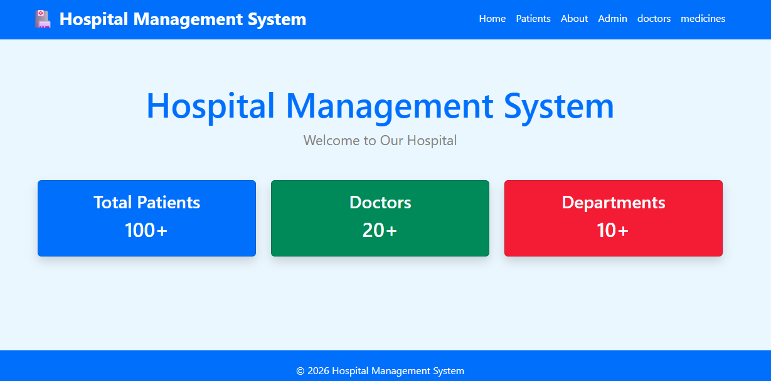
2. Patient List
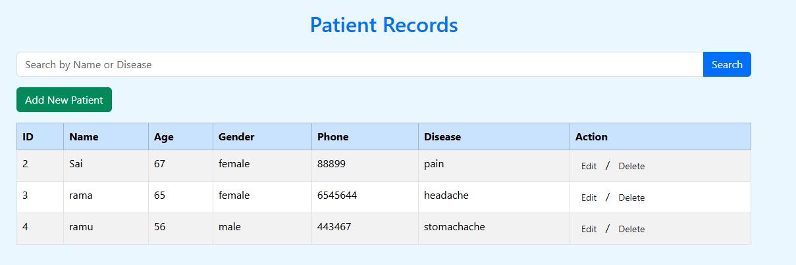
3. Add Patient
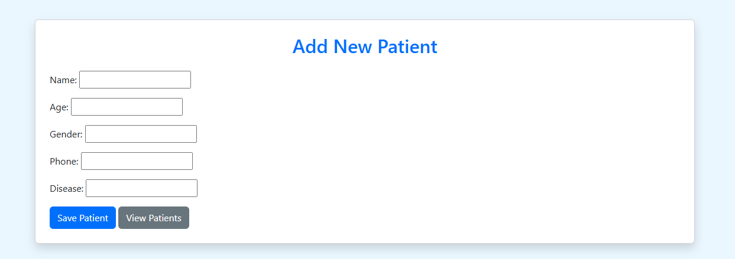
4. Doctor List
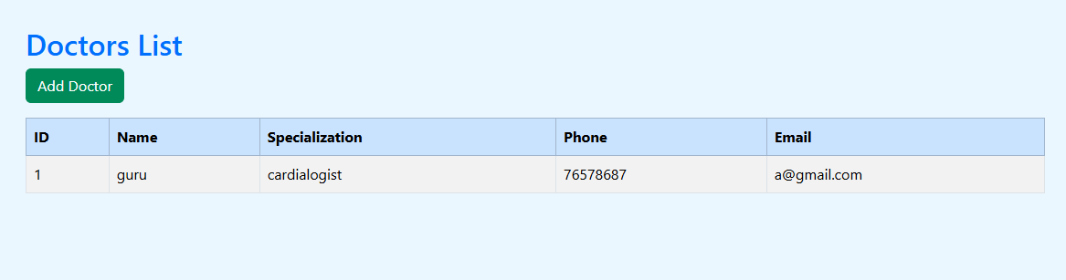
5. Add Doctor
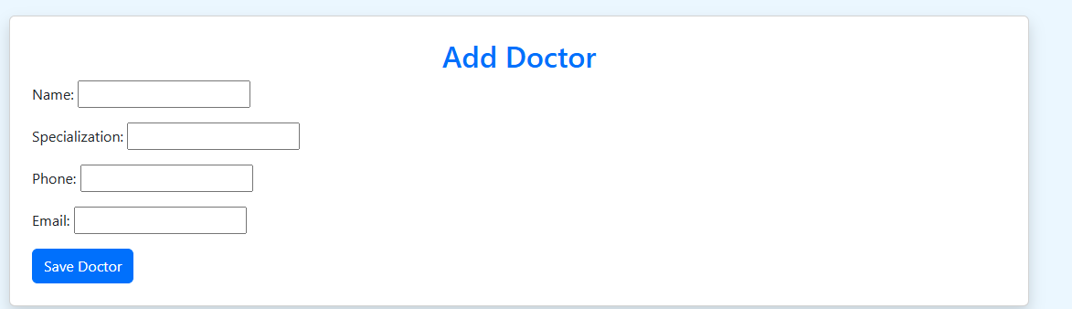
6. Appointment List
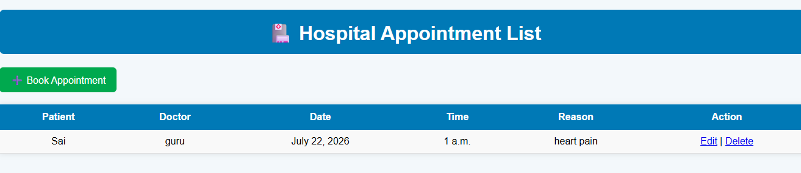
7. Book Appointment
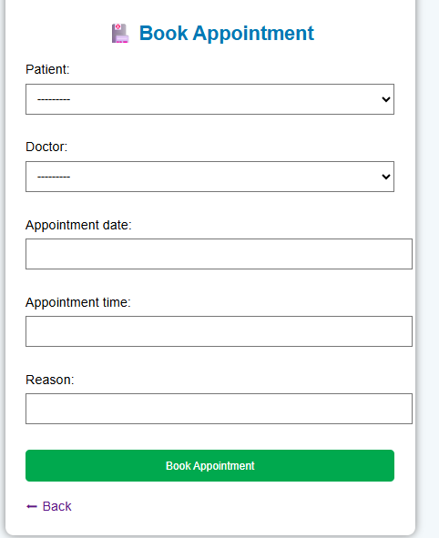
8. Billing List
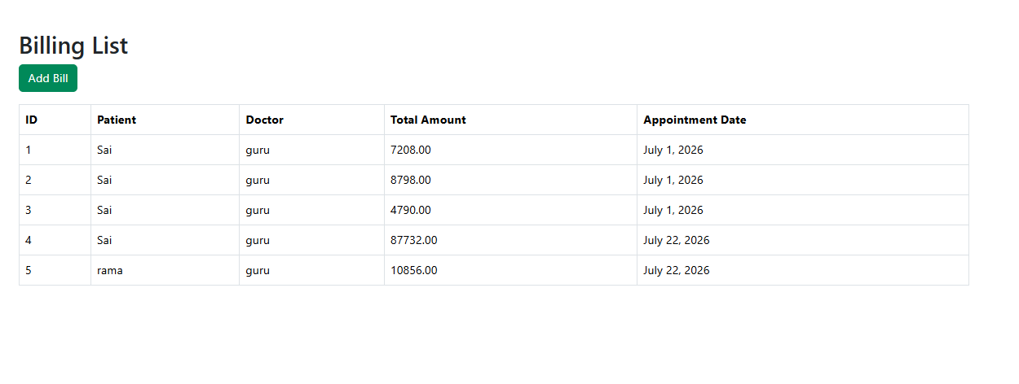
9. Add Bill
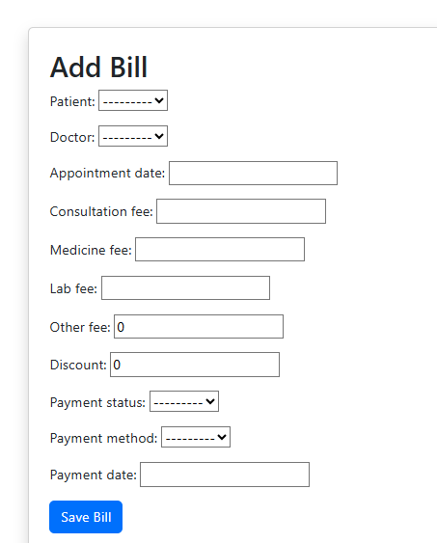
10. Medicine List
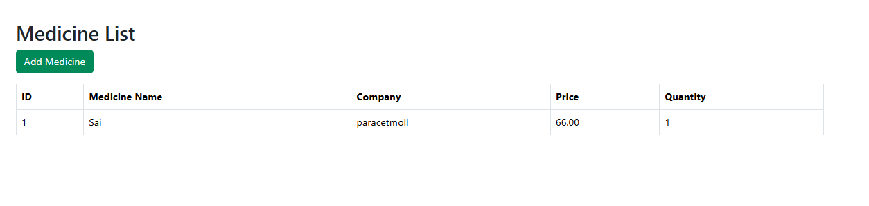
11. Add Medicine
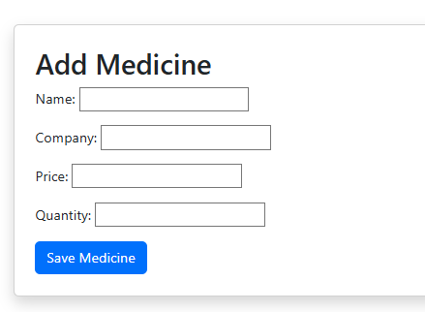
12. Admin Login
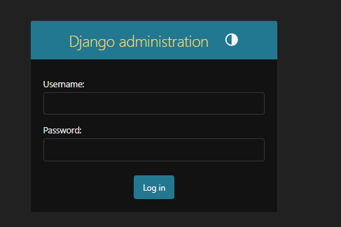
13. Admin Dashboard
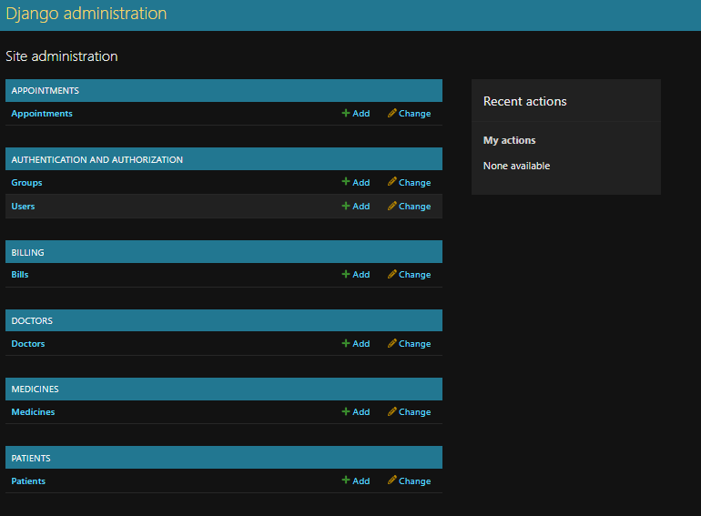
14. Database (SQLite)
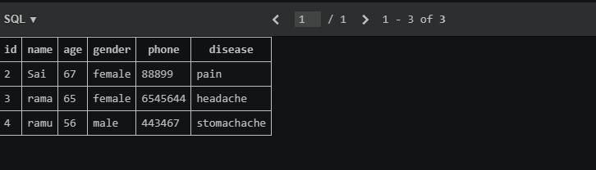

APPENDIX: HOW TO EXPLAIN PROJECT STEPS IN VIVA
During the viva voce examination, you may be asked to explain the steps you followed to build this project. You can explain it in the following order:
- Created a new Django project.
- Created separate apps for Patients, Doctors, Appointments, Billing, and Medicines.
- Created Models and generated the corresponding database tables.
- Created Forms to accept and validate user input.
- Wrote Views to implement CRUD (Create, Read, Update, Delete) operations.
- Configured URLs to route requests to the correct views.
- Built the user interface using HTML Templates and Bootstrap.
- Connected the project to the SQLite database to store and retrieve data.
- Tested all modules to confirm they work correctly.
- Completed the project successfully.

